GOLF HOLIDAY TOP OF THE SOUTH

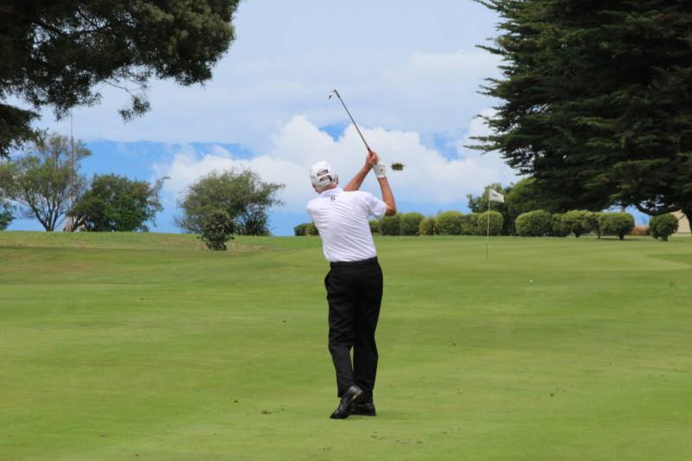
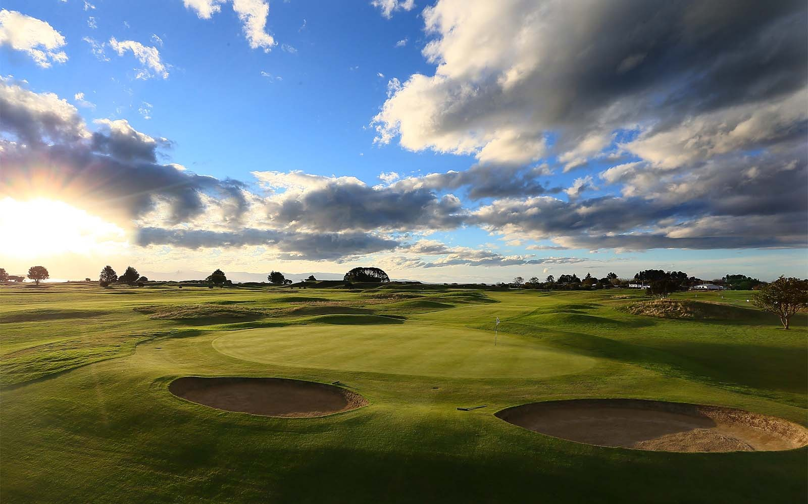

Nelson New Zealand
a great golfing destination.
Nelson Golf Club has partnered with Motueka Golf Club and the Greens Motel to bring you an amazing 3 night golf travel package.

Stay centrally at the Greens Motel. Right next door to Nelson Golf Club.
Play Nelson Links. A superbly crafted links golf course that blends seamlessly into the natural coastal terrain. Please come and experience our unique “True Links Experience”.
The second course on your trip to the Top of the South is at Motueka. Motueka Golf Club was the 2018 Holden Club of the year, and has been described as one of New Zealand’s “hidden gems” by the great Sir Bob Charles. Both Clubs are renowned for their hospitality.
Phil and Jill from The Greens Motel will plan and manage your Nelson Golf holiday from start to finish so all you have to do is focus on your swing!
What’s included:
- 3 nights Motel accommodation at Greens Motel (1 or 2 Bedroom Apartment)
- 2 Rounds of Championship Golf at Nelson Golf Club and Motueka Golf Club
- Warm up bucket of balls at Nelson Golf Club Range
- Light refreshment after each round at the course.
- Preferential car hire rate with Hardy Cars (Starting as low as $25 per day)
- 24-hour help and support, including local activity bookings for your full itinerary.
Cost: $320 per person (normally $440 per person)

*Terms and conditions apply
Minimum of 2 people (at the advertised price, please note there is a surcharge for a smaller group)
Spaces limited, travel must be completed by 14th December 2021

Please phone Phil or Jill on (03) 546-4341 to book

